CST 352 – Lecture 4
Wilsonville, Spring 2022

Ch 7, Virtual/real, paging, GPF/SegFaults

Memory Management
Challenges:
- Protect operating system from programs
- Protect programs from each other
- Memory abstraction for programs
- Efficient use of physical storage (RAM/Cache/Disk)
- Dynamic storage allocation

Memory Fence
Protects OS: OS loaded below this address and no program allowed to access that range
Doesn’t protect programs from each other

Base and Bounds Registers
Protects both OS and programs from each other
Program addresses are with respect to the Base register,
and must remain within Bounds register
Allows many processes to share the same physical memory by swapping out to disk
Allows overlaying memory, allowing program to choose what/when to swap in/out

Virtual Memory
Programs are given an address space from 0 to N
OS maps virtual addresses to physical storage
OS decides when to overlay and swap
Use page faults generated by CPU, when program attempts to access unloaded memory
OS responds to fault and swaps as needed, or
Generates a protection fault if address is invalid

Memory Segments
Variable-sized chunks are allocated as requested by the program
Can lead to external fragmentation…
Freed chunks may be too small to use later
Chunks once placed cannot be moved easily

Memory Pages
Fixed-sized chunks are allocated when needed for programs
Simplest method, but ineffecient and leads to internal fragmentation
Not all memory within a page may be used
Most OS today use paging due to simplicity, speed and relatively cheap memory

Page Table
Maps virtual addresses to physical addresses
Each virtual address consists of a page number and an offset…
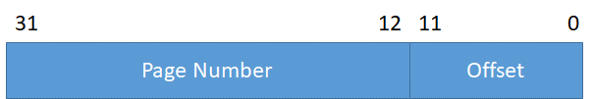

Page number indexes into page table where there is info about the page
Validity bit indicates whether page is currently in primary storage
Other info indicates if anything is currently using the page and permissions
The page table itself requires memory, and could use significant RAM in OS

Forward Mapped Page Tables
Addresses include 2 page references (L1 and L2) and an offset
L1 refers to a page of pages, L2 is an offset into the second level
Allows parts of the page table to be swapped out to disk when not needed

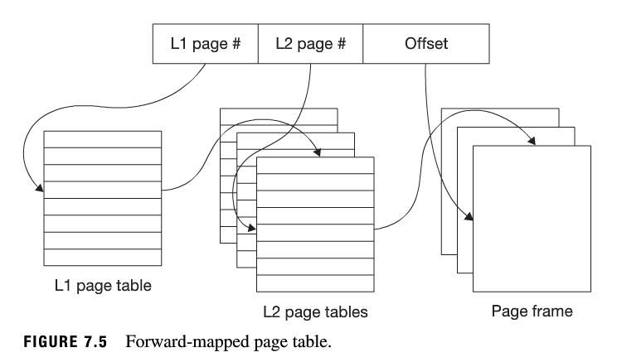

Linear Page Tables
Addresses include a space number and a virtual page number (VPN)
VPN references a page table in a space, spaces being swapped in and out

Hashed Page Tables
Addresses include a page number, which is hashed to look up page
Collisions result in linked lists of page references
Useful for sparsely used, giant memory spaces
Neat, but not used much due to issues with balancing hash table size vs. collisions

Translation Look-aside Buffers (TLB)
Hardware assisted virtual memory translation (supported by modern processors)
Virtual memory translated by CPU, causes a trap for OS to add more table as needed
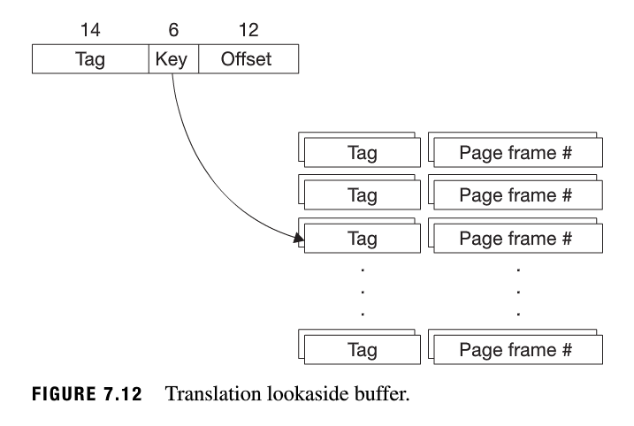

64-bit addresses cause huge page tables
Using techniques above with 4KB pages, 16 petabytes required for just the page table!
Typically 2MB pages used today with hardware assist and many leveled tables

OS Implementation
OS needs three policies to implement memory management:
Fetch Policy – when to bring pages from disk to RAM
Placement Policy – where to put pages in RAM
Replacement Policy – when to put pages back to Disk

Simple Approach…
Demand Paging – only fetch a page when it’s required
Place pages anywhere in RAM, on page boundaries
FIFO Replacement – oldest page is moved out to make room as needed

Results of simple approach…
High overhead for each page fault
Doesn’t make use of caches
Oldest page may be most used!

Improvements on the simple approach…
Read Ahead – fetch adjacent pages w/ requested page (most likely accessed next)
Least Recently Used (LRU) – replace pages not recently accessed

Working-Set concept improves performance…
Thrashing occurrs when processes compete to fetch/replace the pages they need
Can be avoided by determining each process’s working-set:
Memory pages required for program to execute efficiently
Load complete working set when a page fault occurs

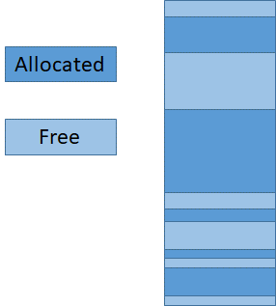
Memory Allocation
Ch 3.3
How to dynamically allocate memory within heap?
Use a “pool” of available memory
Satisfy requests for various amounts
Track “chunks” of memory that are available or allocated
Split/Combine as needed to allocate/free

Simple allocation strategies…
First-fit - Find the first chunk of memory that is big enough to hold requested amount
Best-fit - Find the smallest chunk of memory that is big enough to hold requested amount

Simulations have shown that first-fit is actually the best approach
Best-fit leaves many, very small chunks of memory scattered about

Buddy System
Blocks allocated only in powers of 2 (8 bytes, 16, 32, 64, 128…)
Round up request to a power of 2
Find smallest block available that fits (like best-fit)
If possible, split the identified block in half (recursively) until a block is right-sized
When deallocating, join adjacent blocks if they are the same size

Buddy allocation…

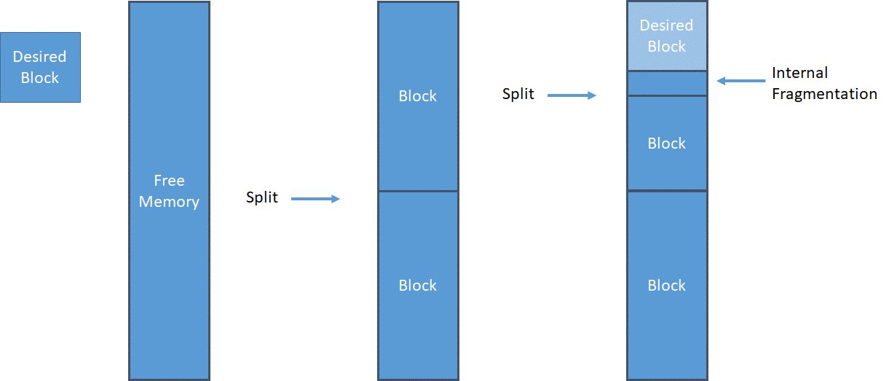

Buddy free…

